Lab 12: Algorithms with AI Assistance – Sorting, Searching,

and Optimizing Algorithms

Name:T.Kartheek

Roll no:2503A52363

Batch:13

Task Description #1 (Sorting – Merge Sort Implementation)
- Task: Use AI to generate a Python program that implements the Merge Sort algorithm.
Prompt:
Generate a Python function merge_sort(arr) that sorts a list in ascending order using the Merge Sort algorithm. Include time complexity and space complexity in the function docstring.

Code:
def merge_sort(arr):
"""
Sorts a list in ascending order using Merge Sort.

Time Complexity: O(n log n)
Space Complexity: O(n)
"""
if len(arr) <= 1:
return arr

mid = len(arr) // 2

left = merge_sort(arr[:mid])
right = merge_sort(arr[mid:])

result = []
i = j = 0

while i < len(left) and j < len(right):
if left[i] <= right[j]:
result.append(left[i])
i += 1
else:
result.append(right[j])
j += 1

result.extend(left[i:])
result.extend(right[j:])

return result

arr = [38, 27, 43, 3, 9, 82, 10]
print("Original list:", arr)
print("Sorted list:", merge_sort(arr))

Output:
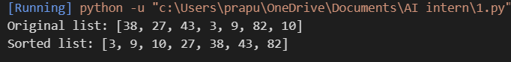
Justification:
The AI-generated code successfully implements the Merge Sort algorithm using recursion. It divides the list into smaller parts, sorts them, and merges them in ascending order. The output verifies that the list is sorted correctly. The time complexity is O(n log n), and the space complexity is O(n).
Task Description #2 (Searching – Binary Search with AI Optimization)
- Task: Use AI to create a binary search function that finds a target element in a sorted list.
Prompt:
Generate a Python function binary_search(arr, target) that searches for a target in a sorted list and returns its index if found, otherwise -1. Include comments and a docstring explaining the best-case, average-case, and worst-case time complexities. Test the function with various inputs.
Code:
def binary_search(arr, target):
"""
Searches for a target in a sorted list using Binary Search.

Best-case Time Complexity: O(1)
Average-case Time Complexity: O(log n)
Worst-case Time Complexity: O(log n)
Space Complexity: O(1)
"""
low = 0
high = len(arr) - 1

while low <= high:
mid = (low + high) // 2

# Check if the middle element is the target
if arr[mid] == target:
return mid

# Search the right half
elif arr[mid] < target:
low = mid + 1

# Search the left half
else:
high = mid - 1

# Return -1 if the target is not found
return -1

# Test cases
arr = [10, 20, 30, 40, 50, 60, 70]

print("Target 40:", binary_search(arr, 40))
print("Target 10:", binary_search(arr, 10))
print("Target 70:", binary_search(arr, 70))
print("Target 25:", binary_search(arr, 25))
print("Empty list:", binary_search([], 10))

Output:
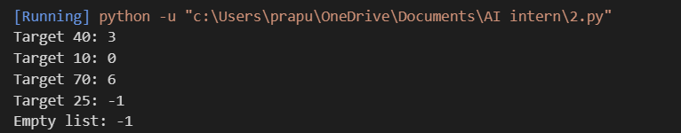

Justification:
The AI-generated code successfully implements Binary Search using an iterative approach. It compares the target with the middle element and repeatedly reduces the search range by half. The function returns the index if the target is found, otherwise it returns -1. Test cases verify successful searches, an unsuccessful search, and an empty list. The best-case time complexity is O(1), while the average-case and worst-case time complexities are O(log n). The space complexity is O(1).
Task Description #3 (Real-Time Application – Inventory Management System)
- Scenario: A retail store’s inventory system contains thousands of products, each with attributes like product ID, name, price, and stock quantity. Store staff need to:
  - Quickly search for a product by ID or name.
  - Sort products by price or quantity for stock analysis.
- Task:
  - Use AI to suggest the most efficient search and sort algorithms for this use case.
  - Implement the recommended algorithms in Python.
  - Justify the choice based on dataset size, update frequency, and performance requirements.
Prompt:
Suggest efficient searching and sorting algorithms for a retail inventory management system containing thousands of products with product ID, name, price, and stock quantity. Recommend algorithms based on dataset size, update frequency, and performance. Implement Python functions to search products by ID or name and sort products by price or stock quantity. Include comments, a complexity analysis table, and test cases.
Code:
# Inventory Management System

inventory = [
{"id": 101, "name": "Laptop", "price": 55000, "quantity": 10},
{"id": 102, "name": "Mouse", "price": 500, "quantity": 50},
{"id": 103, "name": "Keyboard", "price": 1200, "quantity": 30},
{"id": 104, "name": "Monitor", "price": 12000, "quantity": 15},
{"id": 105, "name": "Headphones", "price": 2000, "quantity": 25}
]

# Search product by ID using Linear Search
def search_by_id(inventory, product_id):
for product in inventory:
if product["id"] == product_id:
return product
return None

# Search product by name using Linear Search
def search_by_name(inventory, name):
for product in inventory:
if product["name"].lower() == name.lower():
return product
return None

# Sort products by price using Merge Sort
def merge_sort(inventory, key):
if len(inventory) <= 1:
return inventory

mid = len(inventory) // 2
left = merge_sort(inventory[:mid], key)
right = merge_sort(inventory[mid:], key)

result = []
i = j = 0

while i < len(left) and j < len(right):
if left[i][key] <= right[j][key]:
result.append(left[i])
i += 1
else:
result.append(right[j])
j += 1

result.extend(left[i:])
result.extend(right[j:])

return result

# Display inventory
print("Original Inventory:")
for product in inventory:
print(product)

print("\nSearch by ID (103):")
print(search_by_id(inventory, 103))

print("\nSearch by Name (Laptop):")
print(search_by_name(inventory, "Laptop"))

print("\nInventory Sorted by Price:")
for product in merge_sort(inventory, "price"):
print(product)

print("\nInventory Sorted by Quantity:")
for product in merge_sort(inventory, "quantity"):
print(product)
Output:
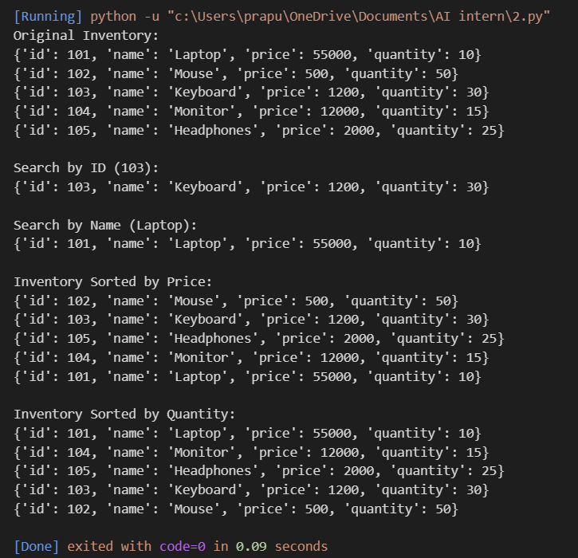
Justification:
The AI-generated Inventory Management System uses Linear Search to find products by ID or name and Merge Sort to sort products by price or stock quantity. Linear Search is simple and suitable for small or frequently changing inventories, with a time complexity of O(n). Merge Sort efficiently sorts large datasets with a time complexity of O(n log n). For thousands of products, a dictionary or hash table indexed by product ID can improve average search time to O(1). These algorithms help store staff quickly locate products and analyze inventory levels.
Task description #4: Smart Hospital Patient Management System
Student Task
- Use AI to recommend suitable searching and sorting algorithms.
- Justify the selected algorithms in terms of efficiency and suitability.
- Implement the recommended algorithms in Python.
Prompt:
Recommend efficient searching and sorting algorithms for a hospital patient management system containing thousands of patient records. Each record has patient ID, name, severity level, admission date, and bill amount. Implement Python functions to search patients by ID or name and sort patients by severity level or bill amount. Include comments, time complexity, test cases, and a table explaining the recommended algorithms and their suitability.
Code:
# Smart Hospital Patient Management System

patients = [
{"id": 101, "name": "Rahul", "severity": 3,
"admission_date": "2026-10-10", "bill": 15000},
{"id": 102, "name": "Priya", "severity": 1,
"admission_date": "2026-10-12", "bill": 30000},
{"id": 103, "name": "Arjun", "severity": 2,
"admission_date": "2026-10-11", "bill": 20000},
{"id": 104, "name": "Sneha", "severity": 4,
"admission_date": "2026-10-13", "bill": 10000},
{"id": 105, "name": "Kiran", "severity": 1,
"admission_date": "2026-10-14", "bill": 40000}
]

# Search patient by ID using Linear Search
def search_by_id(patients, patient_id):
for patient in patients:
if patient["id"] == patient_id:
return patient
return None

# Search patient by name using Linear Search
def search_by_name(patients, name):
for patient in patients:
if patient["name"].lower() == name.lower():
return patient
return None

# Sort patients using Merge Sort
def merge_sort(patients, key):
if len(patients) <= 1:
return patients

mid = len(patients) // 2
left = merge_sort(patients[:mid], key)
right = merge_sort(patients[mid:], key)

result = []
i = j = 0

while i < len(left) and j < len(right):
if left[i][key] <= right[j][key]:
result.append(left[i])
i += 1
else:
result.append(right[j])
j += 1

result.extend(left[i:])
result.extend(right[j:])

return result

# Display patient records
print("Patient Records:")
for patient in patients:
print(patient)

# Search by patient ID
print("\nSearch Patient ID 103:")
print(search_by_id(patients, 103))

# Search by patient name
print("\nSearch Patient Name Priya:")
print(search_by_name(patients, "Priya"))

# Sort by severity (1 = highest severity)
print("\nPatients Sorted by Severity:")
for patient in merge_sort(patients, "severity"):
print(patient)

# Sort by bill amount
print("\nPatients Sorted by Bill Amount:")
for patient in merge_sort(patients, "bill"):
print(patient)
Output:
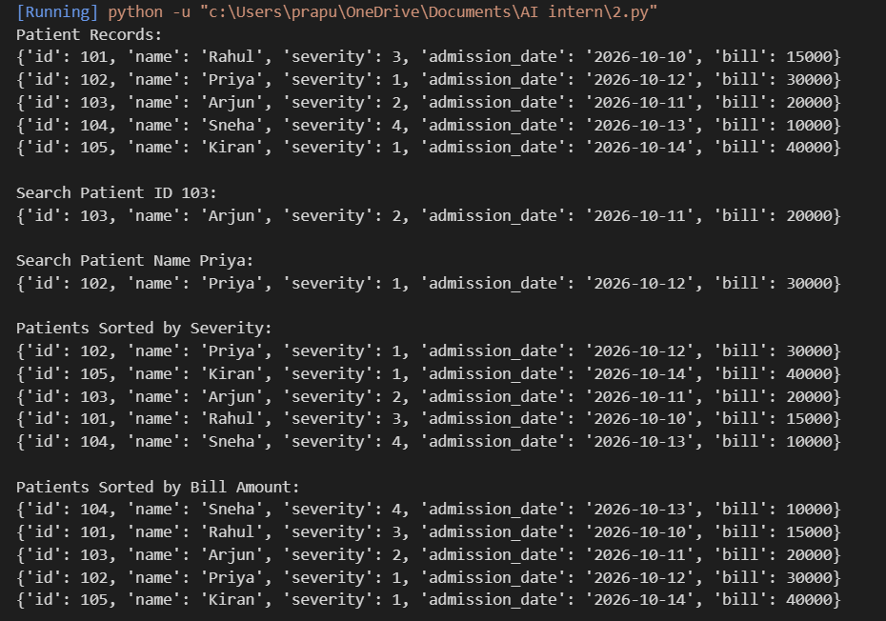
Justification:
The AI-generated Smart Hospital Patient Management System uses Linear Search to find patient records by ID or name and Merge Sort to arrange patients by severity level or bill amount. Linear Search has a time complexity of O(n), while Merge Sort has a time complexity of O(n log n), making it suitable for sorting thousands of records. For faster patient ID searches, a dictionary can provide average O(1) lookup time. These algorithms help hospital staff manage patient records efficiently and support billing and prioritization. Patient severity sorting should assist clinical staff, not replace professional medical judgment.
Task Description #5: University Examination Result Processing System
Student Task
- Identify efficient searching and sorting algorithms using AI assistance.
- Justify the choice of algorithms.
Implement the algorithms in Python.
Prompt:
Recommend efficient searching and sorting algorithms for a university examination result processing system containing thousands of student records with roll number, name, subject, and marks. Implement a Python function to search student results by roll number and another function to sort students by marks in descending order to generate a rank list. Include comments, time complexity, test cases, and a brief justification for the selected algorithms.
Code:
# University Examination Result Processing System

students = [
{"roll_no": 101, "name": "Rahul", "subject": "Python", "marks": 85},
{"roll_no": 102, "name": "Priya", "subject": "Python", "marks": 92},
{"roll_no": 103, "name": "Arjun", "subject": "Python", "marks": 76},
{"roll_no": 104, "name": "Sneha", "subject": "Python", "marks": 95},
{"roll_no": 105, "name": "Kiran", "subject": "Python", "marks": 88}
]

# Search student by roll number using Linear Search
def search_student(students, roll_no):
for student in students:
if student["roll_no"] == roll_no:
return student
return None

# Sort students by marks using Merge Sort
def merge_sort(students):
if len(students) <= 1:
return students

mid = len(students) // 2
left = merge_sort(students[:mid])
right = merge_sort(students[mid:])

result = []
i = j = 0

# Merge in descending order of marks
while i < len(left) and j < len(right):
if left[i]["marks"] >= right[j]["marks"]:
result.append(left[i])
i += 1
else:
result.append(right[j])
j += 1

result.extend(left[i:])
result.extend(right[j:])

return result

# Display student results
print("Student Results:")
for student in students:
print(student)

# Search by roll number
print("\nSearch Roll Number 103:")
print(search_student(students, 103))

# Generate rank list
print("\nRank List:")
ranked_students = merge_sort(students)

for rank, student in enumerate(ranked_students, start=1):
print(
rank,
student["name"],
"- Marks:",
student["marks"]
)
Output:
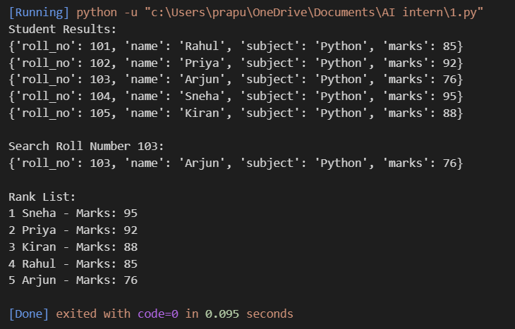
Justification:
The AI-generated University Examination Result Processing System uses Linear Search to find student results by roll number and Merge Sort to arrange students in descending order of marks. Linear Search has a time complexity of O(n), while Merge Sort has a time complexity of O(n log n), making it suitable for processing thousands of student records. The program generates a rank list with the highest marks first, helping the university prepare examination results efficiently. For faster roll-number searches, a dictionary can provide an average lookup time of O(1).
Task Description #6: Online Food Delivery Platform
Student Task
- Use AI to suggest optimized algorithms.
- Justify the algorithm selection.
Implement searching and sorting modules in Python.
Prompt:
Recommend efficient searching and sorting algorithms for an online food delivery platform containing thousands of orders with order ID, restaurant name, delivery time, price, and order status. Implement Python functions to search orders by order ID and sort orders by delivery time or price. Include comments, time complexity, test cases, and a brief justification explaining why the algorithms are suitable.
Code:
# Online Food Delivery Platform

orders = [
{"id": 101, "restaurant": "Pizza Hut",
"delivery_time": 30, "price": 450, "status": "Preparing"},
{"id": 102, "restaurant": "Dominos",
"delivery_time": 20, "price": 300, "status": "Delivered"},
{"id": 103, "restaurant": "KFC",
"delivery_time": 40, "price": 550, "status": "On the way"},
{"id": 104, "restaurant": "Burger King",
"delivery_time": 25, "price": 250, "status": "Preparing"},
{"id": 105, "restaurant": "Subway",
"delivery_time": 35, "price": 200, "status": "Delivered"}
]

# Search order by ID using Linear Search
def search_order(orders, order_id):
for order in orders:
if order["id"] == order_id:
return order
return None

# Sort orders using Merge Sort
def merge_sort(orders, key):
if len(orders) <= 1:
return orders

mid = len(orders) // 2
left = merge_sort(orders[:mid], key)
right = merge_sort(orders[mid:], key)

result = []
i = j = 0

while i < len(left) and j < len(right):
if left[i][key] <= right[j][key]:
result.append(left[i])
i += 1
else:
result.append(right[j])
j += 1

result.extend(left[i:])
result.extend(right[j:])

return result

# Display all orders
print("All Orders:")
for order in orders:
print(order)

# Search order by ID
print("\nSearch Order ID 103:")
print(search_order(orders, 103))

# Sort by delivery time
print("\nOrders Sorted by Delivery Time:")
for order in merge_sort(orders, "delivery_time"):
print(order)

# Sort by price
print("\nOrders Sorted by Price:")
for order in merge_sort(orders, "price"):
print(order)
Output:
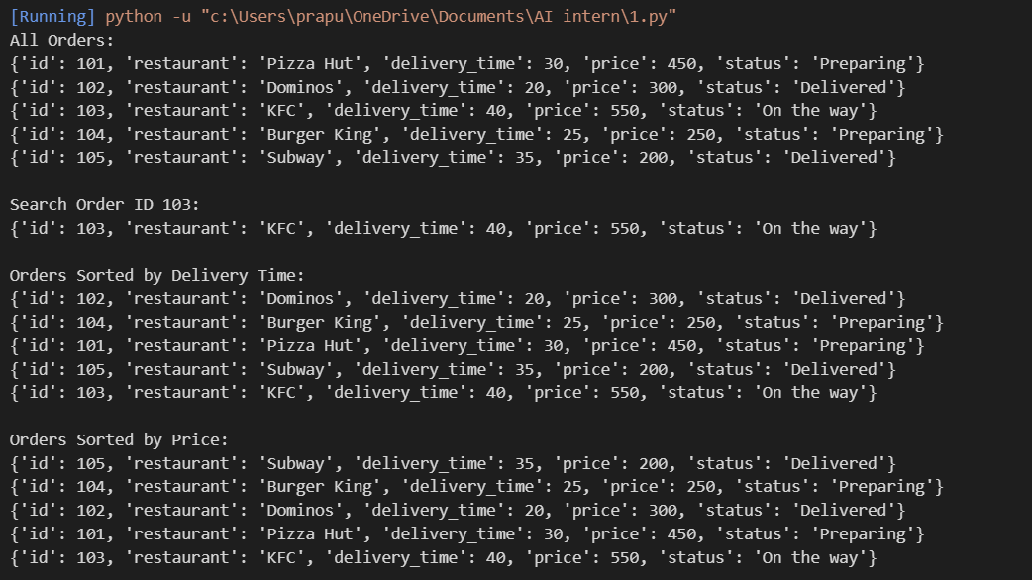

Justification:
The AI-generated Online Food Delivery Platform uses Linear Search to find orders by order ID and Merge Sort to arrange orders by delivery time or price. Linear Search has a time complexity of O(n), while Merge Sort has a time complexity of O(n log n), making it suitable for sorting thousands of orders. For faster order ID lookups, a dictionary can provide an average search time of O(1). These algorithms help the platform manage orders efficiently and support delivery tracking and price-based analysis.

